NAME: Peyyala Naganandhini

NMID: au723921106012

EMAIL: peyyalanaganandini9550@gmail.com

***Abstract- Manual plant watering has been an insistent problem in this era of technological advancement. An automatic sprinkler system for plant and automatic refill system for water fountain is a practical solution to minimize water loss and human errors encountered in manual watering. This project is a microcontroller based automatic refill system for water fountain and automatic sprinkler system for plants. It uses an ATmega328P microcontroller (MCU) IC that serves as the brain incorporated with a Real Time Clock (RTC) module to turn ON the sprinkler pump at a designated time and a soil moisture sensor that monitors the water level in the soil by comparing it with a preprogrammed threshold value. A float switch constantly monitors the water level in the fountain. When the water goes below a desired level, the float switch sends signal to the microcontroller that turns on the refill pump and when the water is at optimal level the refill pump automatically turns off. This project can improve the standard of living for humans and add instant beauty to our surroundings. The benefits of this project cannot be over emphasized.***

***Indexed Terms- Automatic Refill System, Automatic Sprinkler, Water Fountain.***

I. INTRODUCTION

Fountain is a Latin word representing "fontis" whose English meaning is water from a source that pours water into a basin or sprinkles into the air to supply drinking water or for a decorative purpose [1].Water fountains have become very popular over the last decade and everyday people are realizing the benefits a fountain can have. Some of the water fountain benefits are as follows:

1. Stress Relief & Relaxation: Hearing the calming trickling sound of the falling water is soothing, calming, and mesmerizing. The relaxing ambience will easily enhance the serenity of the environment or garden.
2. Indoor & Outdoor décor: The water fountain will add instant beauty to the surroundings.
3. Natural Humidifier: Fountains act as natural humidifiers, adding moisture to a dry surrounding. It can also help indoor plants by adding extra humidity that is lost when heat or air conditioning units are running.
4. Wildlife Attraction: Fountains are great magnets for attracting wildlife, native, while discouraging mosquitoes, making them a great, eco-friendly and safe way to tackle pest control and reintroduce various animal species back to the area, benefitting the local ecosystem.
5. Drowning Out Annoying Sounds A soft flowing water will help you relax and give you a new sound to enjoy, drowning out other sounds around you

[2]*.*

The term “Automatic sprinkler system” simply means automatic plant watering system which is an artificial method of water application to soil to enhance crop life. Nowadays, in the age of advanced technology and electronics, for the life of human being to be simpler and there is a need for many automated systems that can replace or reduce human effort in their daily activities and jobs. One of such system, named as automatic sprinkler system, is a model of controlling irrigation facilities that uses sensor technology to sense the moisture level of the soil with a microcontroller in order to make a smart switching electronic device to help billions of people. Irregular watering leads to the mineral loss in the soil and may end up with rotting the plants [3].

* 1. PROBLEM STATEMENT

Constant evaporation and splashes from the fountain will reduce the water level, and in a long run the water in the fountain reservoir will dry off, therefore we need a system that can constantly monitor the water level. During day-to-day activities many people often forget to water their plants and thus it becomes challenging for them to keep their plants healthy and alive. Also, it is a challenge for farmers to maintain their fields and manage watering of plants during shortage of water.

* 1. AIM AND OBJECTIVES

The aim of this project is to build a water fountain and automatic plant watering system that senses soil moisture using soil moisture sensor and to provide water to the plants or garden automatically with the help of a microcontroller when students are busy with lectures and when schools are going on vacation.

The following are objectives of the studies:

* To minimize water loss and maximize the efficiency of water used.
* To reduce human interference and ensure proper watering
* To build a functional water fountain.
* To prevent over labor of the pumping machine and prevent it from getting bad.

* 1. SIGNIFICANCE OF STUDY

This project is suitable for all electrical and electronics students and hobbyist alike, as well as all interested individuals in agriculture, environmental décor and automation because it changes the manual plant watering to automatic contact-free control system. The continuous extraction of water from the earth is reducing the water level. Also, the unplanned use of water inadvertently results in wastage of water. In an automated watering System using a microcontroller (ATMega328) and a soil moisture sensor, water is supplied only when the moisture in the soil goes below a pre-set threshold value. This saves us a lot of water. Hence, it is more efficient, reliable and plays a vital role in water conservation. The project also gives luxury to those who need it. Other Advantages of this project are: • Highly sensitive

* Saves time
* Works according to the soil condition
* Fit and forget system
* Low cost and reliable circuit • Complete elimination of manpower
* Saves water.

* 1. LITERATURE REVIEW

This section presents the review of related literatures which includes work done on the topic by past researchers. This section will be divided into two segments as follows:

1. Automatic sprinkler system incorporated with ground moisture sensor and real-time clock triggering system.
2. Water fountain incorporated with fountain auto refill.

# 1. Automatic Sprinkler System incorporated with Ground Moisture Sensor and Real-Time Clock triggering

Automatic plant watering system has become much common with advancement in technologies. There are several types of plant watering system, depending on the level of automation needed. Some important plant watering system are illustrated below.

# A. Arduino Based Automated Plant Watering System with Message Alert

The block diagram in figure 1 gives the short illustration of what the framework will do in this specific system. Arduino microcontroller is used to control the entire procedure of this Plant Watering System. The use of soil sensor circuit is straight forwardly associated with a computerized soil sensor stick with digital pins connected to Arduino. An idea for GSM module in this project is to notify the user by sending SMS. The schematic of the overall system is shown in figure 1 below [4].

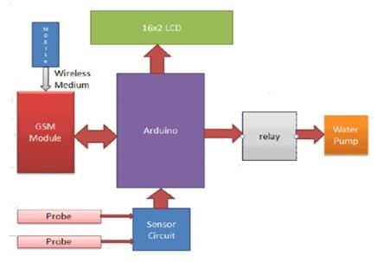

Fig -1: Block diagram of Arduino based automated plant watering system with message alert.

# B. Real-Time Clock Controlled Herbal Garden Watering System

Hygrometer sensors are usually used in smart garden watering system. However, they are known for corroding quickly, particularly if watering is required every day. This system takes advantage of RTC to trigger the watering of an herbal garden. The major components used in this project as shown in figure 2 are: 12V power pack, real time clock, relay, buzzer, and Arduino Nano. An Arduino Nano is used because it is smaller and takes less space. The real-time clock module is connected to the Arduino. The Arduino is programmed to turn ON the pump at a designated time. The pump is connected to the relay and 12V power through a 12mm PVC tube. The water supply is enabled through a 20 litre tank, enough to keep the watering for a few weeks. A float switch is connected to the bottom of the tank, that triggers an alarm if the water level goes below a critical level for the pump [5].

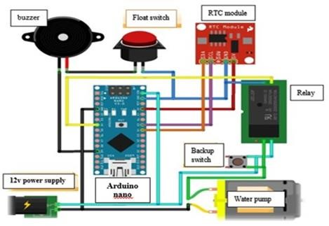

Fig-2: Schematic diagram of Real-Time Clock

2. *Water Fountain Incorporated with Fountain Auto Refill*

# C. Fountain Auto Refill System

Automatic refill system provides a simple method to refill a fountain or an aquarium automatically when the water level is below a desired threshold. The reduction in water level might be caused by evaporation or water splash. The system consists of an electronic water pump, a float-switch and a microcontroller. When the water gets too low, the float switch sends a pulse to the microcontroller, and the microcontroller activates the pump. To operate a pump using an Arduino microcontroller, a relay is needed to switch on and off a separate power supply.

Aquarium auto refill with Arduino is a simple example of how to use a float switch, small liquid pump and a relay to refill an aquarium once the water level gets too low. But this same technique can be used for pet dishes, water fountains, or any other number of similar applications [6].

VI. METHODOLOGY (DESIGN AND

CONSTRUCTION)

The design procedure involves determining the appropriate materials and components to be used in the circuit as well as their properties; which includes components values, voltage ratings and maximum current ratings. These could be actualized easily by consulting the data sheet provided by component’s manufacturer. The analysis of each unit will be carried out in detail, for example, the value of capacitor in the power supply can only be determined by mathematical analysis where a formula is used and some important parameters such as total load current and frequency of mains voltage are used to calculate for the capacitance.

# A.Block Diagram of the System

The block diagram in this system is used to describe the most basic and less detailed description and operation of the automatic sprinkler and auto refill system. It shows the hardware used in the project which includes the Atmega328P microcontroller IC, real-time clock module, soil moisture sensor, float switch, submersible pump, refill pump, sprinkler pump, etc. as shown in figure 3.

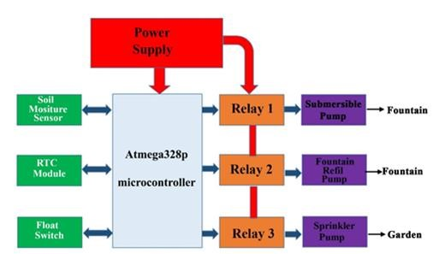

Fig -3: Block Diagram of the System

The ATmega328P microcontroller IC is programmed using the Arduino IDE software. The function of the RTC is to keep track of the system in real time and to trigger the system at a designated time. The moisture sensor senses the level of moisture in the soil. The water pump supplies water to the plants and refills the fountain. The submersible pump is submerged in the reservoir of the fountain and moves water to the aerator or fountain piece where the water emerges.

Although this project uses ATmega328P microcontroller to control the water pumps, but the microcontroller cannot be used to trigger the pump directly. The relay is used to interface the microcontroller with the water pumps. The moisture sensor measures the level of moisture in the soil and sends the signal to the microcontroller when watering is required. Water pump supplies water to the plants until the desired moisture level is reached.

*1. ATmega328P Microcontroller IC* ATmega328P is a low-power 8-bit microcontroller based on the enhanced RISC architecture. By executing powerful instructions in a single clock cycle, the ATmega328P achieves throughputs approaching 1MIPS per MHz allowing the system designed to optimize power consumption against processing speed.

The device is manufactured using Atmel high density non-volatile memory technology. The ATmega328P AVR is supported with a full suite of program and system development tools including: C compilers, macro assemblers, program debugger/simulators, incircuit emulators, and evaluation kits [7].

# Pins Description

Figure 4 shows the pictorial view of ATmega328P chip when it is used in place of the Arduino UNO or vice versa. Figure 5 below shows ATmega328P microcontroller pins and its description. The 14 digital input/output pins can be used as input or output pins by using pinMode(), digitalWrite() and digitalRead() functions in Arduino programming. Each pin operates at 5V and can provide or receive a maximum of 40mA current and has an internal pull-up resistor of 20-50K Ohms which are disconnected by default.

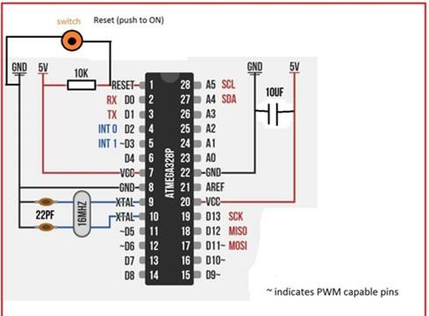

Fig -4: ATmega328P Microcontroller IC 25

# 2. Soil Moisture Sensor

The soil moisture sensor module is used to detect the moisture level of the soil. It measures the volumetric content of water inside the soil and gives the moisture level as output. The moisture sensor consists of two probes that are used to detect the moisture of the soil. These two probes are used to pass the current through the soil to the LM393 comparator IC, and then the sensor reads the resistance to get the moisture values. This Moisture sensor module consists of a moisture sensor, Resistors, Capacitor, Potentiometer, Comparator (LM393 IC), Power and Status LED in an integrated circuit. The moisture sensor probes are coated with immersion gold that protects Nickel from oxidation. as shown in figure 6.

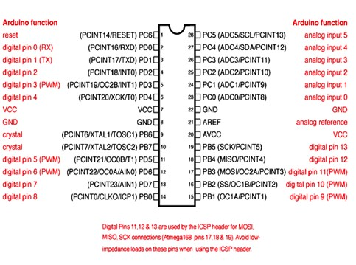

Fig -5: ATmega328P microcontroller IC pin mapping

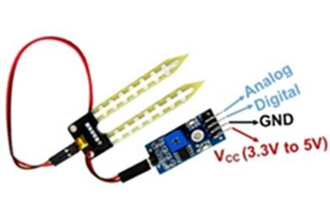

Fig -6: Soil moisture sensor

# 3. Realtime Clock (DS3231)

The DS3231 is a low-cost, extremely accurate I2C real-time clock (RTC) with an integrated temperaturecompensated crystal oscillator and crystal. The device incorporates complementary metal oxide semiconductor (CMOS) battery to maintains accurate timekeeping when main power to the device is interrupted. The integration of the crystal resonator enhances the long-term accuracy of the device. A precision temperature-compensated reference voltage and comparator circuit monitors the status of VCC to detect power failures, to automatically switch to the backup supply when necessary and to provide a reset output signal. Additionally, the reset pin is monitored as a pushbutton input for generating a reset externally. The pictorial view of the RTC (DS3231) module is shown in figure 7.

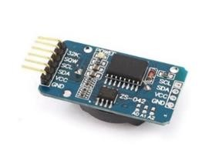

Fig -7: Realtime Clock (DS3231)

# 4. RELAY

The term Relay generally refers to a device that provides an electrical connection between two or more points in response to the application of a control signal. The most common and widely used type of electrical relay is the electromechanical relay (EMR). The most fundamental control of any equipment is the ability to turn it "ON" and "OFF". The easiest way to do this is using switches to interrupt the electrical supply. Although switches can be used to control something, they have their disadvantages. The biggest one is that they must be manually (physically) turned "ON" or "OFF". Also, they are relatively large, slow and only switch small electrical currents. Electrical Relays, however, are basically electrically operated switches that come in many shapes, sizes and power ratings suitable for all types of applications. Relays can also have single or multiple contacts with the larger power relays used for high voltage or current switching being called "contactors". The most common form of electromechanical relay consists of an energizing coil called the "primary circuit" wound around a permeable iron core. This iron core has both a fixed portion called the yoke, and a moveable spring-loaded part called the armature, that completes the magnetic field circuit by closing the air gap between the fixed electrical coil and the moveable armature. The armature is hinged or pivoted allowing it to freely move within the generated magnetic field closing the electrical contacts that are attached to it. Connected between the yoke and armature is normally a spring (or springs) for the return stroke to "reset" the contacts back to their initial rest position when the relay coil is in the "deenergized" condition, i.e, turned "OFF". These phenomena are shown in figure 8.

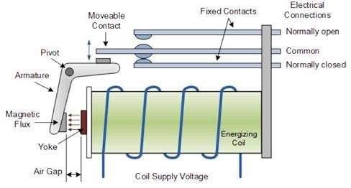

Fig -8: Electromechanical relay construction

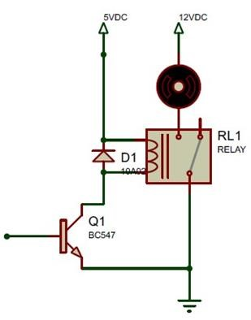

Fig -9: Relay circuit

When the relay is connected in a circuit a diode is connected in parallel with the relay coil, this diode is called the freewheeling diode, its purpose is to protect the transistor from the stored charges in the relay coil. The transistor is used to drive the relay coil because the current that the coil draws is higher than the microprocessor current, the circuit of a relay is shown in figure 9.

# 5. Float Switch

The float switch is a device that is used to sense the level of water in a tank, aquarium or pond. It can be used to actuate a pump, an indicator, an alarm or other devices. The float switch as shown in figure 10 below is a compact vertically mounted device which can be mounted at either top or bottom of a tank (by supplied ‘O’ ring and nut) to either rise and fall for actuation (by an internal magnet) of sealed reed relay, the float switch is pre wired with flying output leads.

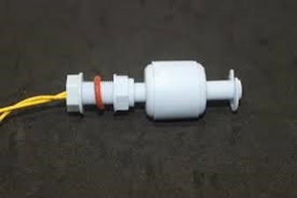

Fig -10: Float switch

*6. Power Supply Design and Analysis* A power supply is an electrical device that supplies electric power to an electric load. The primary function of a power supply is to convert electric current from a source to a desired voltage, current, and frequency to power the load. Some power supplies are separate standalone pieces of equipment, while others are built into the load appliances that they power. An AC to DC power supply converts an alternating current (AC) source to a direct current (DC) supply. The most basic AC to DC power supply consists of a transformer, rectifier diodes, and a capacitor. The block diagram of the power supply is shown in figure 11 below. The Power Supply unit deriving power from the AC mains

(source) performs several tasks which includes;

i. It changes (in most cases reduces) the level of the source voltage to a value suitable for driving the load circuit. ii. It produces a DC supply from a pure AC wave. iii. It prevents any form of AC from appearing at the

output.

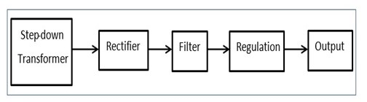

Fig -11: Power Supply block diagram

A DC power supply can be designed by following the following steps as follows:

1. Determine the output voltage and current needed.
2. Pick a linear regulator that can handle the required current.
3. Pick a bridge rectifier that can handle the required current.
4. Pick filter capacitors that limit the rectifier ripple to a reasonable value.
5. Pick a transformer with a secondary voltage rating to accommodate all the voltage drops.
6. Add a fuse to the primary side of the transformer (and a heatsink if needed) for the rectifier and regulator.

i. *Cumulative Load Current and Voltage* The various load voltage and current of the sensors and modules used for this project are calculated as shown in table 1 below:

Table -1: cumulative load current and voltage

|  |  |  |
| --- | --- | --- |
| Loads | Max  current  (mA) | Rated voltage |
| ATmega328P  microcontroller | 200 | 5v |
| RTC (DS32131) | 0.5 | 3V |
| Soil Moisture Sensor | 15 | 5V |
| Refill pump | 50 | 5V |
| Submersible pump | 400 | 12V |
| Relay | 70 | 5V |
| Sprinkler pump | 350 | 12V |
| LED | 50 | 5V |
| TOTAL | 1135.5 |  |

Table 1 above shows the cumulative load currents from all loads and the voltage ratings of individual load. The total current is given as 1135.5mAmps, and the voltages as seen from table 4 above will be 12volts, 3volts and 5volts.

# ii. Linear Regulator That Can Handle the Required Currents

From the load tables seen that the required rated voltages are 5volts and 12volts, for that reason I have decided to use LM317 and L7805 IC regulators.

LM317 is a three-terminal 1.5A adjustable voltage regulator, guaranteed thermal regulation, current limit constant with temperature, it has the following

specifications from the data plate;

* Input-output voltage differential 35 V
* Line regulation typically 0.00 %/V
* lead temperature (Soldering, 10 seconds) 300 °C
* Adjustable output down to 1.2 V

L7805 is a member of L78XX family, it is a series of three terminal positive regulator IC. It is useful in a wide range of applications. These regulators employ internal current limiting, thermal shut-down and safe area protection, making it essentially indestructible. If adequate heat sinking is provided, they can deliver over 1A output current. Although designed primarily as fixed voltage regulators, these devices can be used with external components to obtain adjustable voltage and currents. It has a maximum output current of 1.5 Amperes.

1. Rectifier That Can Handle the Required Current.A rectifier is used to convert the ac voltage to dc voltage. For this project the KBJ406G bridge rectifier will be used because it can withstand the load current. It a maximum current rating of 3ampere and maximum repetitive reverse voltage of 50V-700V, the RMS rating of the bridge rectifier is 35V, meanwhile this project has a minimum of 21V RMS.

1. *Filter Capacitor That Limits the Rectifier Ripple* A filter capacitor connected directly to the output of the rectifier as shown in the circuit in Figure 28 is used to reduce the bumps as well as compensate for periods where the waveform would otherwise have been flat.

Calculations on choosing an appropriate rating of the filtering capacitor is determined as follows:

VRec = Vac − VD − − − − − − − − − − − − − − − − − − − 1

|  |  |
| --- | --- |
| Where:  transformer | Vac = AC voltage from the |
|  | VRec = Rectified voltage. |
|  | VD = Voltage drop of the rectifier. |
|  | VP = Peak voltage. |

VP  x VRec − − − − − − − − − − − − − − − − − 2

dQ = CdV − − − − − − − − − − − − − − − −3

Therefore, if the voltage changes from

Vmax to Vmin the charge delivered by the capacitor is dQ

I = − − − −4 dt

Or the magnitude of the charge delivered by the capacitor

Q = C(Vmax − Vmin)

Therefore Q = CdV − − − − − − − − − − − −5

T I

dt = = − − − − − − − − − − − − − − − −

2 2f

− 6

CdV

I = − − − − − − − − − − − − − − − − − − dt

− 7

I ∗ dt I

C 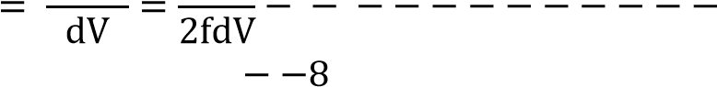

I

C 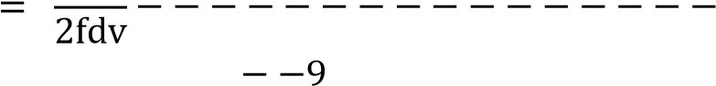

|  |  |
| --- | --- |
| Where: | I= maximum load current |
|  | f = supply frequency |
|  | dv = ripple voltage. |

dv = VP 100%

10

The equation above shows that the ripple in a rectifier depends upon the load current and the circuit parameter like f and C. The product FC is therefore an important design factor for the rectifiers. The voltage which the capacitor sees is not the average voltage Vrms but Vpeak A rule for safety and durability, the working voltage of the filter capacitor is made to be twice the calculated value of the peak voltage.

The value of capacitor for the filter can be determined using equation 9 above;

I

|  |  |
| --- | --- |
| C = − − − − − − − − − − − − − − − −  2fdv  − −9 |  |
| Where: I= maximum load current  1135.5mA  f = supply frequency = 50Hz | = |

dv = ripple voltage. = VP 

20%

100%

dv =15*

100%

The total load current is increased by 50percetnt in order to increase the flexibility and reliability of the power supply, therefore; Imax = 1.1355+(1.1355*0.5) = 1.7Amperes

C = 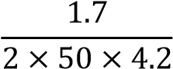 = 4.0476 × 10−3Farads

C = 4047uF

# v. A Transformer with voltage Rating to Accommodate Load Voltage

A 15volt, 2 Amperes transformer will be suitable for this project. Because the load drawn by regulator, ripple, and rectifier will increase the required voltage, but for a 15volt step down transformer the effective value of voltage will be approximately 21volts which will be enough for all the load. a fuse was connected to the primary side of the transformer for protection against over voltage and short circuit from the supply.

vi. Power Supply Circuit Diagram The power supply consists of transformer TR1 which step down 220v to 15vac, the bridge rectifiers BR1 converts the 15v ac to dc equivalent. Figure 12 below is the schematic diagram of the power supply. U1 and U2 are the 5v and 12v regulator respectively, C1 is the ripple filter capacitor, C2 and C3 are capacitors that are used to improve the output impedance of the power supply, resistors R1 and R2 form a voltage divider for the adjustable terminal the regulator (U2).

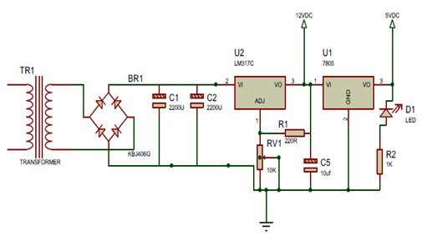

Fig -12: Power Supply circuit diagram.

*7. Software Design of The Project* The software design of the project involves flowcharting, programming and coding. A

programmer’s job involves writing instructions, but a professional programmer usually does not just sit down at a computer keyboard and start typing, rather he/she follows a program development circle [8].

The program cycle can be broken down into at least seven steps:

1. Understand the problem.
2. Plan the logic. iii. Code the program.
3. Use software (a compiler or interpreter) to translate the program into machine language.
4. Test the program.
5. Put the program into production. vii. Maintain the program.

The problem has been properly understood, the problem involves designing an automatic refill system and an automatic sprinkler system with ground moisture sensor, which can also be triggered ON at designated time. With this the next step in this project is to plan the logic which the program will run. They will be done vividly in the next section with the help of flow chart.

# Flow Chart of the system

Flowchart is a pictorial representation of the logic flow of the program, it helps to visualize more easily how the program statement will connect. The chart will be divided into two sections, one section is for the automatic sprinkler system and the other is for the automatic refill system. Figure 13 below is a pictorial representation of how the automatic refill system will operate, Figure 14 is a pictorial representation of the sprinkler system

# Program

The ATmega328P microcontroller can be programmed with the Arduino IDE software. The Arduino microcontroller is an easy to use yet powerful single board computer that has gained considerable traction in the hobby and professional market. The Arduino is open source which means hardware is reasonably priced and development software is free. The IDE has the main sections, the void setup and void loop, the set up runs once immediately the circuit is turned. In the setup section, the programmer declares all the variables and setup the pin mode which could be input or output.

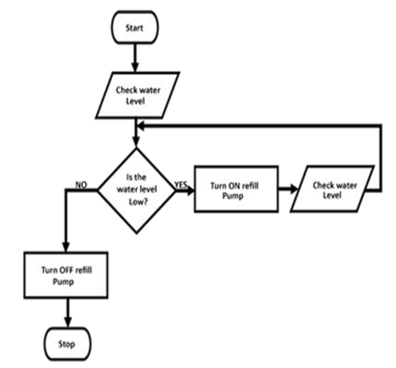

Fig -13: Automatic Refill System flow chart

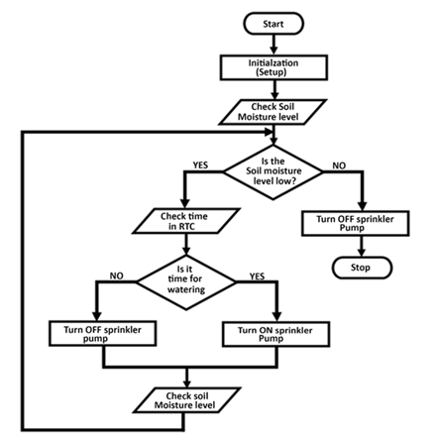

Fig- 14: Automatic Sprinkler System flow chart

The loop section is where all the main code and instruction are written because it runs repeatedly. The Arduino is capable of which translating and executing about 300,000 lines of C source code per second. The source code used in this project will be shown in the appendix section

*8. Hardware Design of the system.*The hardware consists of electronic component and electromechanical devices that comprises of physical devices. Electric hardware design is the analysis and synthesis of electronic circuit components. It deals with physical components and their interrelationships.

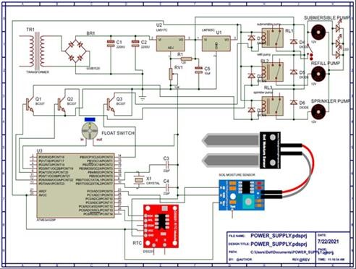

Fig -15: Circuit Diagram

Figure 15 is the circuit diagram of the system, TR1 is a stepdown transformer that steps down 230VAC to 15VAC, C1 and C2, and C5 are filter capacitors they are also used to stabilize the load fluctuations. U1 and U2 are voltage regulators, U2 is LM317C is a variable voltage regulator, for this project it is set as a 12V voltage regulator whereas L7805C is a constant 5V voltage regulator. D1, D2, D3, D4, D5 and D6 are PN junction diode they are used to protect the transistor and regulators from charges stored in the relay coil and motor coil, they can also e called freewheeling diodes. Q1, Q2 and Q3 are NPN transistors, they are biased to operate as a switch and current amplifiers. R1 and RV1 are resistor that form a voltage divider circuit for U2 voltage regulator. RL1, RL2 and RL3 are relays used to trigger the pumps. U3 is the ATmega328P microcontroller chip.

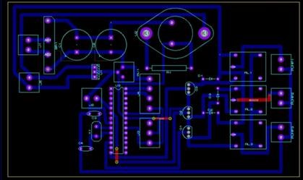

Fig -16: PCB view of the project

Figure 16 shows the PCB printout out the circuit design, the above image is printed on a plane PCB and it is etched with hydrogen peroxide mixed with hydrochloric acid in a ratio of 1:2 , afterwards it is cleaned with Tina to clear the surface. The designated components holes are drilled as shown in figure 17. The board is placed in a PCB holding apparatus incorporated with a magnifying glass and LED to make all components visible afterwards components are placed on PCB and soldered.

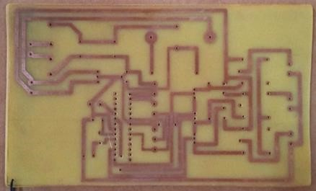

Fig -17: PCB after drilling components holes

The project is enclosed in a box as shown in figure 18 below, all components have been soldered, the wires seen in the image are female headers that will accommodate the float switch, soil moisture sensor and RTC module.

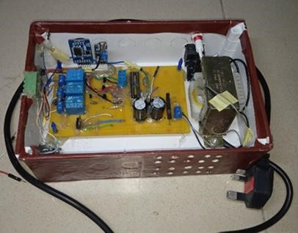

Fig -18: internal view of the project.

# 9. Water Fountain Construction

The water fountain is a two tier, water fall fountain, its constructed with concrete and reinforced with quarter rod and bounding wire. It consists of three bowl, the biggest is the reservoir that houses the submersible pump, float switch and decorative LEDs, the second in size is the first tier and the small one is the first tier, it is positioned at the top.



Fig -19: Fountain bowl

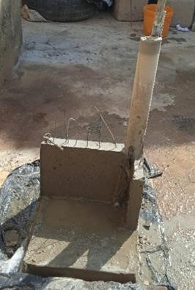

Fig -20: Fountain stand

The fountain concrete components are built using 6mm diameter mild steel bars as reinforcement and concrete mix ratio of 1:1.5:3 by weight in kg (that is cement, fine aggregate and coarse aggregate) producing concrete grade of M20 per square millimetres, the pre cast bowl

and fountain stand are shown in figures 19 and 20

VII. PERFOMANCE EVALUATION

When the system is turned ON the water fountain will automatically refill itself and start running. Whenever it loses water, it automatically refills itself. The sprinkler system is preprogramed to turn ON at 7am, 11am, and 6pm, water the plant for 15minuites until the soil moisture sensor indicates that the water level in the soil is at a desired level. The setup of the project is shown in figure 21 below.

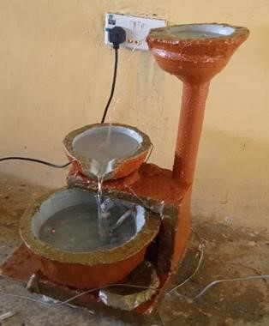

Fig -21: pictorial view of the functional water fountain

# 1. Testing

Several tests were carried out before, during and after the construction work. These include the primary and secondary test. The primary test was carried out before and during the construction work while the secondary test was carried out towards the end of the construction and after the construction work.

## 1.1 Primary Test

Under the primary test, two tests were carried out which are; continuity test and insulation test. A continuity test is the checking of an electric circuit to see if current flows (that it is, in fact, a complete circuit). On this project, a continuity test was carried out on the PCB strips to ensure continuity from one end to the other (no breakage of connection and no bridges). This is also referred to as an open circuit or short circuit test. The instrument used to perform this action is a digital mustimeter.

An electrical insulation test is a resistance test that is performed between one or more electrical circuits of the same subsystem. The test often reveals problems that occurred during assemblies, such as wrong component, improper component placement/orientation, and wire insulation that may cause inadvertent shorting or grounding to chassis, in turn, compromising electrical circuit quality and product safety. This test was carried out on the project to ensure no leakage current between the insulation of conductors.

## 1.2 Secondary Test

This is the type of test that is performed during and towards the end of the construction. Two tests were carried out under this test; power supply test and software test.

# i. Power Supply Test

The power supply unit of +5V and +12V were tested for the output voltage under no-load and full-load conditions. Under no-load, the voltage of the +5V supply section was measured to be 4.95V while that of the +12V supply was measured to be 11.94V. At full- load, the respective voltages were measured as 4.85V and 11.83V.

# ii. Software Test

Software testing is a process, to evaluate the functionality of a software application or program with the intention of finding whether the developed software meets the specified requirements and to identify the defects to ensure that the product is defect-free in order to produce the quality product. Software testing is needed in order to detect the bugs in the software and to test if the software meets the intended requirements. The software used in this project is the Arduino IDE written in C# programming language. The system was tested using Arduino UNO development board with other modules connected to it.

CONCLUSION

The problems associated with manual watering inspired the development of this project. The system utilizes a Real time clock module that sends signal to turns ON the sprinkler system at designated time and with the help of a soil moisture sensor the system could be able to detect when the water in the soil is enough in order to turn OFF the pump. In other words, the RTC is the master and the soil moisture sensor serve as the slave. The water fountain is a concrete structure with decorative submersible LEDs. It utilizes a submersible pump to operate and a float switch to monitor the water level, the automatic refill is done by a separate pump and a reservoir. The system is designed with an ATmega3289 microcontroller that serves as its brain. From all the test evaluation carried out the system is very reliable and has performed efficiently.

Thus, the project “DESIGN AND CONSTRUCTION OF A WATER FOUNTAIN WITH WATER LEVEL MONITORING AND AUTOMATIC SPRINKLER SYSTEM WITH GROUND MOISTURE SENSOR

AND REAL TIME CLOCK” has been designed successfully and tested to function automatically. Since this system have been proven to work satisfactory, the aims and objective of this project have been achieved. Furthermore, this project can be used to improved standard of living, give our crops healthier live, make our environment greener and serve as a means of income if the project designer decides to commercialize it.

RECOMMENDATION

This project is open for improvement, for further development of the system the following recommendations can be put into considerations:

1. To incorporate an LCD that displays the water level in the soil and the status of the system in real time. This will make the work look more professional.
2. To provide an interface that could be used to control the system manually and change the preprogramed turn ON time. This will make the work to be more friendly.
3. Integrating a technology which can be used to monitor the water level in the tank, this will prevent the sprinkler pump and auto refill pump from dry running.
4. Provision of uninterrupted power supply UPS (back up battery) to enable the fountain to be functional during blackout.
5. To make the soil sensing system to be smart in order to adapt automatically to different soil type.

APPENDIX

/*WATER FOUNTIAN WITH WATER LEVEL

MONITORING AND AUTOMATIC SPRINKLER SYSTEM WITH GROUND MOISTURE SENSOR

AND REALTIME CLOCK. the following code will constantly monitor the water level in the fountain and also turn on the sprinkler system at 7:00am, 11:00am, and 6:00pm, the soil moisture sensor will constantly monitor the water level in the soil and turn the system off when the water is at optimal level.

*/

//define the input/output pins int refilpump = 6; // sets pin 7 as the output pin to the refill pump

int submersiblepump = 8; //declear pin 8 as

submersible pump pin const int Relay = 4;

const int analogPin = A0; // pin that the soil moisture sensor is attached to const int threshold = 350; // an arbitrary threshold level that tell the amount of water in the soil is enough #define floatswitch 3 //delear pin 3 as floatswitch pin

// Init the DS3231 using the hardware interface

#include <DS3231.h>

DS3231 rtc(SDA, SCL); Time t; void setup(){

Serial.begin(9600); //set up serial monitor rtc.begin(); // Initialize the rtc object //define the input/output pins pinMode(Relay, OUTPUT); // set pin 4 ie relay pin

as output digitalWrite(Relay, LOW); pinMode(refilpump, OUTPUT); pinMode(submersiblepump, OUTPUT); pinMode(floatswitch, INPUT_PULLUP); //sets floatswitch pin which is pin 2 as input} void loop () { // put your main code here, to run repeatedly: t = rtc.getTime(); Serial.print(t.hour);

Serial.print(" hour(s), ");

Serial.print(t.min);

Serial.print(" minute(s)"); Serial.println(" "); delay (1000); if(digitalRead(floatswitch)== HIGH){ digitalWrite(submersiblepump,LOW); //Tturn off submersib pump

digitalWrite(refilpump, LOW); //turn on the pump} else{

digitalWrite(refilpump, HIGH);//turn on the pump digitalWrite(submersiblepump,HIGH ); //Turn off submersible pump } delay(1); int moisturelevel = analogRead(analogPin); //declare analogue in value as the moisture level Serial.println(moisturelevel); if( moisturelevel > threshold) {

// t.hour is the hour to turn On and t.min is the minutes to turn on

// the following lines will turn on at 7:00am to 7:15am if (t.hour ==7 && t.min ==0) {digitalWrite(Relay,HIGH); Serial.println("pump ON"); } else if (t.hour ==7 && t.min ==1) {digitalWrite(Relay,HIGH); Serial.println("pump ON"); } else if (t.hour ==7 && t.min ==2) {digitalWrite(Relay,HIGH); Serial.println("pump ON"); } else if (t.hour ==7 && t.min ==3) {digitalWrite(Relay,HIGH); Serial.println("pump ON"); } else if (t.hour ==7 && t.min ==4) {digitalWrite(Relay,HIGH); Serial.println("pump ON"); else if (t.hour ==7 && t.min ==5) {digitalWrite(Relay,HIGH); Serial.println("pump ON"); } else if (t.hour ==7 && t.min ==6) {digitalWrite(Relay,HIGH); Serial.println("pump ON"); } else if (t.hour ==7 && t.min ==8) {digitalWrite(Relay,HIGH); Serial.println("pump ON"); } else if (t.hour ==7 && t.min ==9) {digitalWrite(Relay,HIGH); Serial.println("pump ON"); } else if (t.hour ==7 && t.min ==10) {digitalWrite(Relay,HIGH); Serial.println("pump ON"); } else if (t.hour ==7 && t.min ==11) {digitalWrite(Relay,HIGH); Serial.println("pump ON"); } else if (t.hour ==7 && t.min ==12) {digitalWrite(Relay,HIGH); Serial.println("pump ON"); } else if (t.hour ==7 && t.min ==13) {digitalWrite(Relay,HIGH);

|  |
| --- |
| else if (t.hour ==7 && t.min ==14) {digitalWrite(Relay,HIGH); {digitalWrite(Relay,HIGH); Serial.println("pump ON"); } Serial.println("pump ON"); } else if (t.hour ==11 && t.min ==15) else if (t.hour ==7 && t.min ==15) {digitalWrite(Relay,HIGH); {digitalWrite(Relay,HIGH); Serial.println("pump ON"); }  Serial.println("pump ON"); } //////////////////////////  //// // the following lines will turn it on at 6:00pm to  //the following line will turn it on at 11:00am to 6:15pm  11:15am else if (t.hour ==18 && t.min ==0)  else if (t.hour ==11 && t.min ==0) {digitalWrite(Relay,HIGH); {digitalWrite(Relay,HIGH); Serial.println("pump ON"); } Serial.println("pump ON"); } else if (t.hour ==18 && t.min ==1) else if (t.hour ==11 && t.min ==1) {digitalWrite(Relay,HIGH); {digitalWrite(Relay,HIGH); Serial.println("pump ON"); } Serial.println("pump ON"); } else if (t.hour ==18 && t.min ==2) else if (t.hour ==11 && t.min ==2) {digitalWrite(Relay,HIGH); {digitalWrite(Relay,HIGH); Serial.println("pump ON"); } Serial.println("pump ON"); } else if (t.hour ==18 && t.min ==3) else if (t.hour ==11 && t.min ==3) {digitalWrite(Relay,HIGH); {digitalWrite(Relay,HIGH); Serial.println("pump ON"); } Serial.println("pump ON"); } else if (t.hour ==18 && t.min ==4) else if (t.hour ==11 && t.min ==4) {digitalWrite(Relay,HIGH); {digitalWrite(Relay,HIGH); Serial.println("pump ON"); } Serial.println("pump ON"); } else if (t.hour ==18 && t.min ==5) else if (t.hour ==11 && t.min ==5) {digitalWrite(Relay,HIGH); {digitalWrite(Relay,HIGH); Serial.println("pump ON"); } Serial.println("pump ON"); } else if (t.hour ==18 && t.min ==6) else if (t.hour ==11 && t.min ==6) {digitalWrite(Relay,HIGH); {digitalWrite(Relay,HIGH); Serial.println("pump ON"); } Serial.println("pump ON"); } else if (t.hour ==18 && t.min ==8) else if (t.hour ==11 && t.min ==8) {digitalWrite(Relay,HIGH); {digitalWrite(Relay,HIGH); Serial.println("pump ON"); } Serial.println("pump ON"); } else if (t.hour ==18 && t.min ==9) else if (t.hour ==11 && t.min ==9) {digitalWrite(Relay,HIGH); {digitalWrite(Relay,HIGH); Serial.println("pump ON"); } Serial.println("pump ON"); } else if (t.hour ==18 && t.min ==10) else if (t.hour ==11 && t.min ==10) {digitalWrite(Relay,HIGH); |

Serial.println("pump ON"); } {digitalWrite(Relay,HIGH);

Serial.println("pump ON"); }

else if (t.hour ==11 && t.min ==11)

{digitalWrite(Relay,HIGH); [1]

Serial.println("pump ON"); } else if (t.hour ==11 && t.min ==12)

{digitalWrite(Relay,HIGH);

Serial.println("pump ON"); } [2]

else if (t.hour ==11 && t.min ==13) {digitalWrite(Relay,HIGH); Serial.println("pump ON"); } else if (t.hour ==11 && t.min ==14) REFERENCES

Bordeaux and p. prevot, "fountain," 2006.

[Online]. Available: http;//en.m.wikipedia.org/wiki/fountain#cite_ref1. [Accessed 10 February 2021].

A. Liddel, “water fountain benefits,” Net Health

Shops, LLC, [Online]. Available:

http://serenityhealth.com/water-fountainbenefits/. [Accessed 10 February 2021].

1. Y. Y. Nu, S. S. Lwin and W. W. Maw,

“Automatic Plant Watering System using

Arduino UNO for University Park",”

International Journal of Trend in Scientific Research and Development, vol. 3, no. Issue-4,, pp. 902-906, june 2019.

1. Saddam, "Arduino based Automatic Plant Irrigation System with Message Alert," Arduino based Automatic Plant Irrigation System with Message Alert, 15 February 2018.
2. M. Dullo, “Real-Time Clock Controlled Herbal Garden Watering System,” [Online]. Available: https://create.arduino.cc/projecthub/maximiliandullo/real-time-clock-controlled-herbal-gardenwatering-system-d19e45. [Accessed 11 February 2021].
3. robotgeek, "Aquarium Auto Refill With Arduino," 28 march 2016. [Online]. Available: http://www.instructables.com/id/AquariumAuto-Refill-With-Arduino/. [Accessed 15 febuary 2021].
4. Atmel coporation, "ATmega328P," Datasheet, 2015.
5. J. Farrell, Programming Logic And Design, 6th ed., Canada: course technology cengage learning, 2011.